Q1. Debugging Selection Sort Code

Given Code
def selection_sort(arr):
n = len(arr)
for i in range(n):
min_idx = i
for j in range(i+1, n):
if arr[j] > arr[min_idx]: # ERROR
min_idx = j
arr[i], arr[min_idx] = arr[min_idx], arr[i]
return arr

Execution:

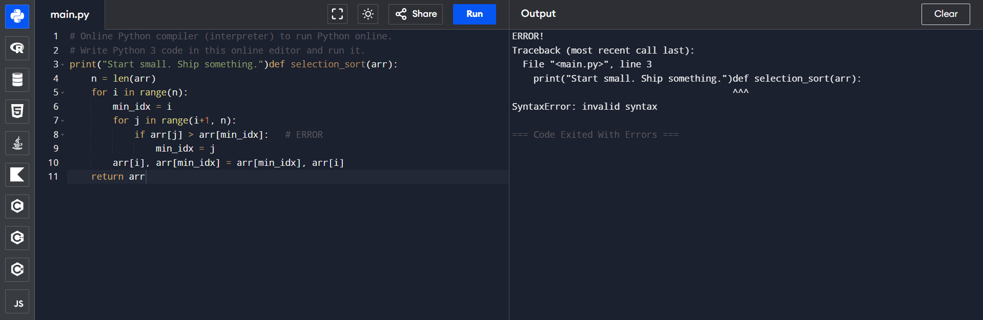

Errors in the Code
Error 1: Comparison Operator is wrong
Problem:
if arr[j] > arr[min_idx]:
Reason:
For selection sort , ascending order should find the smallest element
The givrn condition is finding the largest element instead.
Correction:
if arr[j] < arr[min_idx]:

Execution:

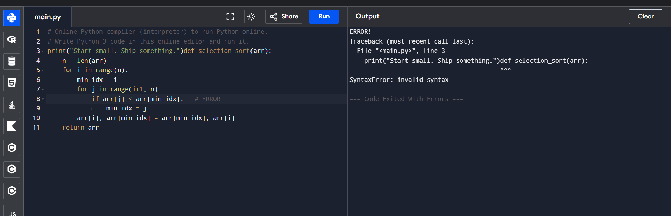

Error 2: Unnecessary Swapping
The algorithm swaps even when:
min_idx == i
This means the element is already in the correct position.
Correction:
if min_idx != i:
arr[i], arr[min_idx] = arr[min_idx], arr[i]
This avoids unnecessary swaps.

Execution:

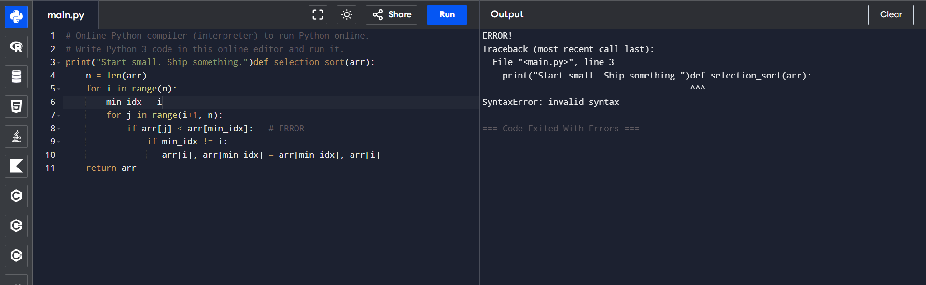

Step-by-Step Debugging:

Step 1
Initialize:
min_idx = i
We need to assume that the first unsorted element to be the minimum.

Step 2
Search for the minimum element.
Incorrect:
if arr[j] > arr[min_idx]:
Correct:
if arr[j] < arr[min_idx]:

Step 3
Swap only if needed.
Incorrect:
arr[i], arr[min_idx] = arr[min_idx], arr[i]
Correct:
if min_idx != i:
arr[i], arr[min_idx] = arr[min_idx], arr[i]

The corrected Selection Sort Code:
def selection_sort(arr):
"""
Sorts the given list in ascending order using Selection Sort.
"""
n = len(arr)
# Traverse through the array
for i in range(n - 1):
min_idx = i
# Find the smallest element
for j in range(i + 1, n):
if arr[j] < arr[min_idx]:
min_idx = j
if min_idx != i:
arr[i], arr[min_idx] = arr[min_idx], arr[i]
return arr

# Example
arr = [64, 25, 12, 22, 11]
print("Original Array:", arr)
sorted_arr = selection_sort(arr)
print("Sorted Array:", sorted_arr)

Execution:

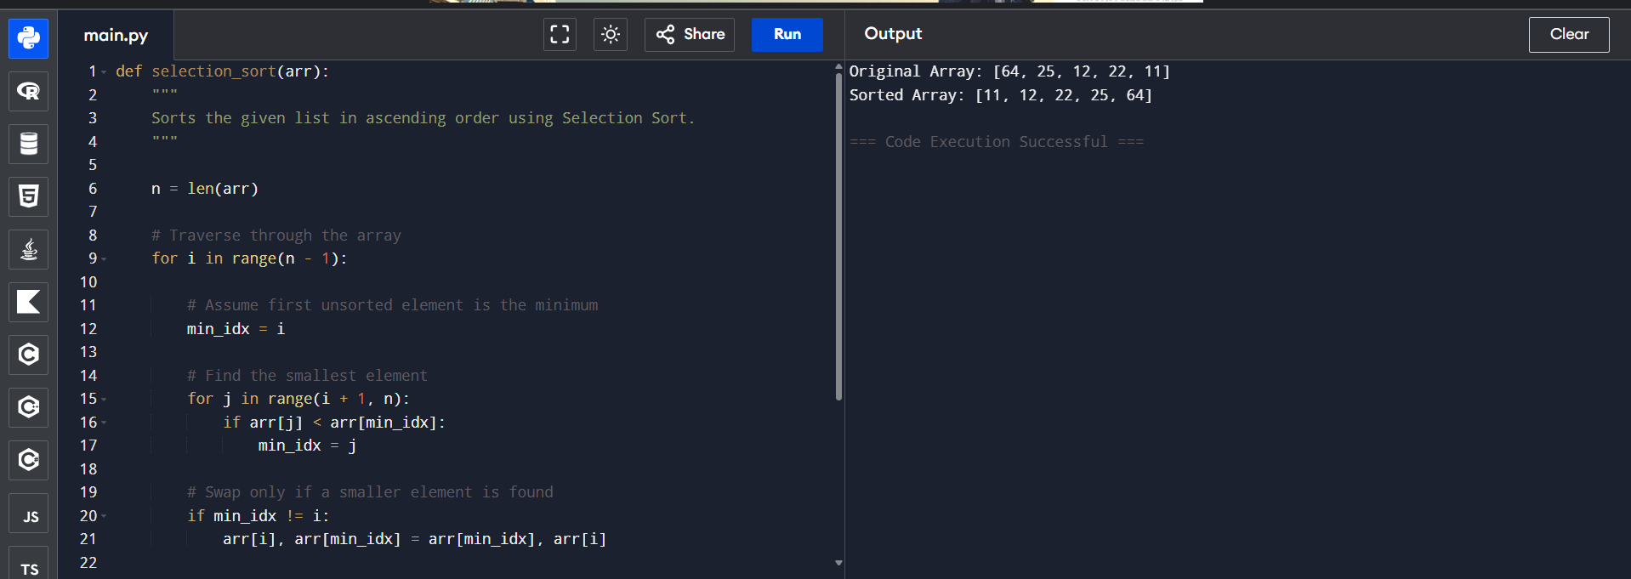

Algorithm: Selection Sort (Ascending Order)
Input: Array A of size n
Output: Sorted array in ascending order
- Start.
- Read the array A and its size n.
- For each position i from 0 to n-2:
  - Assume the current element is the smallest:
    - min_index = i
  - Search the remaining unsorted part of the array (i+1 to n-1):
    - If A[j] < A[min_index], update min_index = j.
  - If min_index is not equal to i, swap A[i] and A[min_index].
- Repeat until all elements are sorted.
- Display the sorted array.
- Stop.

Search Technique: Linear Search

Explanation:
- During each iteration, Selection Sort searches the unsorted portion of the array one element at a time.
- It compares every element with the current minimum element.
- This sequential scanning is known as Linear Search (Sequential Search).
Example:
Array: [64, 25, 12, 22, 11]
- Pass 1: Search linearly for the smallest element → 11
- Pass 2: Search linearly in [25, 12, 22, 64] → 12
- Pass 3: Search linearly in [25, 22, 64] → 22
- Pass 4: Search linearly in [25, 64] → 25

Time Complexity Analysis:
Case | Time Complexity
Best Case | O(n²)
Average Case | O(n²)
Worst Case | O(n²)

Why?
The algorithm always scans the remaining unsorted portion to find the minimum element.
Number of comparison:(n−1)+(n−2)+⋯+1=2n(n−1)
Therefore, comparisons remain O(n²) regardless of the input order.
Space Complexity:
O(1) (in-place sorting).

